**Difference between Internet and WWW**

1. **Internet :**  
   The internet is a globally connected network system facilitating worldwide communication and access to data resources through a huge collection of personal, public, business, academic and government networks. it’s governed by agencies just like Internet Assigned Numbers Authority (or IANA) that establish universal protocols.

**2. World Wide Web (WWW) :**  
World Wide Web (WWW), byname Web, is leading information retrieval service of web (the worldwide computer network). Online gives users access to a huge array of documents that are connected to every other by means of hypertext or hypermedia links—i.e., hyperlinks, electronic connections that link related pieces of data so as to permit a user quick access to them. Hypertext allows the user to pick a word or phrase from text and thereby access other documents that contain additional information concerning that word or phrase.

**Difference between Internet and WWW :**

|  |  |  |
| --- | --- | --- |
| **S.No.** | **INTERNET** | **WWW** |
| 1 | Internet is a global network of networks. | WWW stands for World wide Web. |
| 2 | Internet is a means of connecting a computer to any other computer anywhere in the world. | World Wide Web which is a collection of information which is accessed via the Internet. |
| 3 | Internet is infrastructure. | WWW is service on top of that infrastructure. |
| 4 | Internet can be viewed as a big book-store. | Web can be viewed as collection of books on that store. |
| 5 | At some advanced level, to understand we can think of the Internet as hardware. | At some advanced level, to understand we can think of the WWW as software. |
| 6 | Internet is primarily hardware-based. | WWW is more software-oriented as compared to the Internet. |
| 7 | It is originated sometimes in late 1960s. | English scientist Tim Berners-Lee invented the World Wide Web in 1989. |
| 8 | Internet is superset of WWW. | WWW is a subset of the Internet. |
| 9 | The first version of the Internet was known as ARPANET. | In the beginning WWW was known as NSFNET. |
| 10 | Internet uses IP address. | WWW uses HTTP. |

# HTTP

* HTTP stands for **HyperText Transfer Protocol**.
* It is a protocol used to access the data on the World Wide Web (www).
* The HTTP protocol can be used to transfer the data in the form of plain text, hypertext, audio, video, and so on.
* This protocol is known as HyperText Transfer Protocol because of its efficiency that allows us to use in a hypertext environment where there are rapid jumps from one document to another document.
* HTTP is similar to the FTP as it also transfers the files from one host to another host. But, HTTP is simpler than FTP as HTTP uses only one connection, i.e., no control connection to transfer the files.
* HTTP is used to carry the data in the form of MIME-like format.
* HTTP is similar to SMTP as the data is transferred between client and server. The HTTP differs from the SMTP in the way the messages are sent from the client to the server and from server to the client. SMTP messages are stored and forwarded while HTTP messages are delivered immediately.

## **Features of HTTP:**

* **Connectionless protocol:** HTTP is a connectionless protocol. HTTP client initiates a request and waits for a response from the server. When the server receives the request, the server processes the request and sends back the response to the HTTP client after which the client disconnects the connection. The connection between client and server exist only during the current request and response time only.
* **Media independent:** HTTP protocol is a media independent as data can be sent as long as both the client and server know how to handle the data content. It is required for both the client and server to specify the content type in MIME-type header.
* **Stateless:** HTTP is a stateless protocol as both the client and server know each other only during the current request. Due to this nature of the protocol, both the client and server do not retain the information between various requests of the web pages.

AD

## **HTTP Transactions**

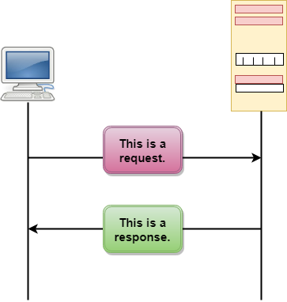

The above figure shows the HTTP transaction between client and server. The client initiates a transaction by sending a request message to the server. The server replies to the request message by sending a response message.

## **Messages**

HTTP messages are of two types: request and response. Both the message types follow the same message format.

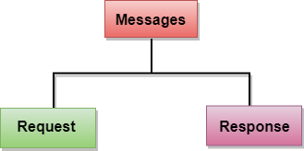

**Request Message:** The request message is sent by the client that consists of a request line, headers, and sometimes a body.

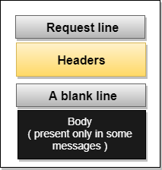

**Response Message:** The response message is sent by the server to the client that consists of a status line, headers, and sometimes a body.

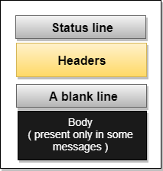

# HTML Elements

An HTML file is made of elements. These elements are responsible for creating web pages and define content in that webpage. An element in HTML usually consist of a start tag <tag name>, close tag </tag name> and content inserted between them. **Technically, an element is a collection of start tag, attributes, end tag, content between them**.

Following is the list of the some main elements used in HTML:

|  |  |  |  |
| --- | --- | --- | --- |
| **Start tag** | **Content** | **End tag** | **Description** |
| <h1> ...... <h6> | These are headings of HTML | </h1>??..</h6> | These elements are used to provide the headings of page. |
| <p> | This is the paragraph | </p> | This element is used to display a content in form of paragraph. |
| <div> | This is div section | </div> | This element is used to provide a section in web page. |
| <br> |  |  | This element is used to provide a line break. ( void element) |
| <hr> |  |  | This element is used to provide a horizontal line. (void element) |

**What is image mapping :**  
In image mapping an image is specified with certain set of coordinates inside the image which act as hyperlink areas to different destinations. It is different from an image link since in image linking, an image can be used to serve a single link or destination whereas in a mapped image, different coordinates of the image can serve different links or destinations.

#### Elements required in Mapping an Image :

There are three basic html elements which are required for creating a mapped image.

1. **Map :**It is used to create a map of the image with clickable areas.
2. **Image :**It is used for the image source on which mapping is done.
3. **Area :**It is used within the map for defining clickable areas.

#### Steps to create a mapped image :

* **Determining Image size :**  
  Determining the size of the image is very important because if the size of the image is changed then the area coordinates will also require updation.

## **HTML Layout Elements**

HTML has several semantic elements that define the different parts of a web page:

|  |  |
| --- | --- |
| HTML5 Semantic Elements | * <header> - Defines a header for a document or a section * <nav> - Defines a set of navigation links * <section> - Defines a section in a document * <article> - Defines an independent, self-contained content * <aside> - Defines content aside from the content (like a sidebar) * <footer> - Defines a footer for a document or a section * <details> - Defines additional details that the user can open and close on demand * <summary> - Defines a heading for the <details> element |

# HTML Table

**HTML table tag** is used to display data in tabular form (row * column). There can be many columns in a row.

We can create a table to display data in tabular form, using <table> element, with the help of <tr> , <td>, and <th> elements.

In Each table, table row is defined by <tr> tag, table header is defined by <th>, and table data is defined by <td> tags.

HTML tables are used to manage the layout of the page e.g. header section, navigation bar, body content, footer section etc. But it is recommended to use div tag over table to manage the layout of the page .

## **HTML Table Tags**

|  |  |
| --- | --- |
| **Tag** | **Description** |
| <table> | It defines a table. |
| <tr> | It defines a row in a table. |
| <th> | It defines a header cell in a table. |
| <td> | It defines a cell in a table. |
| <caption> | It defines the table caption. |
| <colgroup> | It specifies a group of one or more columns in a table for formatting. |
| <col> | It is used with <colgroup> element to specify column properties for each column. |
| <tbody> | It is used to group the body content in a table. |
| <thead> | It is used to group the header content in a table. |
| <tfooter> | It is used to group the footer content in a table. |